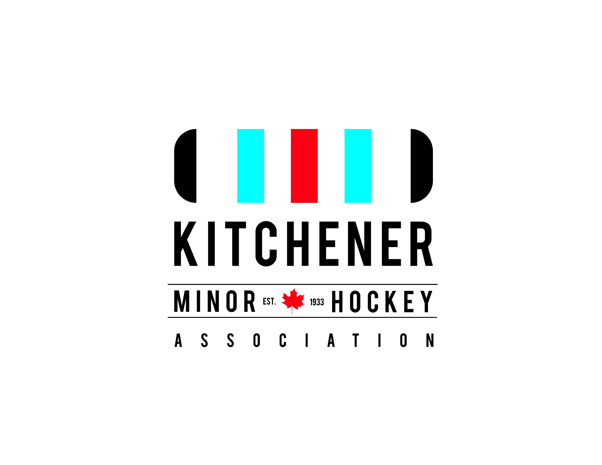
HL REQUEST FOR TENDER
Re: Kitchener Minor Hockey House League Jerseys
The Kitchener Minor Hockey Association invites you to participate in providing us with a quotation to supply the KMHA House League jerseys for our House League teams for the upcoming 2018/19, 2019/20 and 2020/21 hockey seasons. The specifications are as follows.
Specs:
Approximately 78 teams requiring Uniforms in 2018/2019, each team requires 1 set of jerseys, for an estimated total of 1326 jerseys. KMHA will also require 1326 pairs of knit socks in colours to accompany jerseys. Each age division will not duplicate a colour.
Approximately 76 teams requiring Uniforms in 2019/2020 and 2020/21 seasons, each team requires 1 sets of jerseys, for an estimated total of 1326 jerseys. KMHA will also require 1326 pairs of knit socks in colours to accompany jerseys. Size and colour break down to follow before each season. Each age division will not duplicate a colour. (and colours must have significant differentiation and be approved by KMHA before production)
Team totals are a best projection and may vary slightly based upon enrollment. KMHA reserves the right to adjust team totals by 20% up or down based upon enrollment and will communicate no later than May 1st prior to the season in question any changes in order numbers.
The Jersey will be of equal or greater quality to a Kamazu LITE series 2 colour House League Program hockey sweater.
Decorations (Small amount of flexibility in heights based upon size of sweater, please include suggested alterations in your tender)
  - Team Name & KMHA logo (10”) Silk screened to front of the jersey in colour.
  - Team Sponsors Silk Screened to the bottom back of the Jersey in 4 inch lettering, one colour
  - 2 colour (except on white)Canadian Flag Silk Screened on upper right chest
  - 12 inch player numbers Silk Screened to the Back of the Jersey in one colour
  - Double hit White on Darks
Numbering
Player numbers for 17 sweater set – 1, 4, 6, 9, 10, 11, 14, 15, 16, 23, 44, 55, 66, 77, 87, 91, 31
All garments are to be sorted, collated and delivered in team sets by age group, complete with matching socks. F.O.B. KMHA equipment room. Delivery no later than Aug 21, of the season year. Date may vary dependent on KMHA providing the supplier with Sponsor names for silk screening.
2018-19 HL. Jersey Order

# Teams | Age Group | Team Name | Jersey Colour | Sizes for Age group 17 per team
1 | IP | Senators | Dependent on Supplier | 7 Youth Medium
2 | IP | Nordiques |  | 10 Youth Large
3 | IP | Leafs
4 | IP | Oilers
5 | IP | Red Wings |  | Socks
6 | IP | Blackhawks |  | 17 – 20”
7 | IP | Canadiens
8 | IP | Stars
9 | IP | Bruins
10 | IP | Hurricanes
# Teams | Age Group | Team Name | Jersey Colour | For all teams in the Division
A Pool
1 | Minor Novice | Canucks | Dependent on Supplier | 3 Youth Medium
2 | Minor Novice | Capitals |  | 6 Youth Large
3 | Minor Novice | Flyers |  | 8 Youth X – Large
4 | Minor Novice | Kings
B Pool
5 | Minor Novice | Flames
6 | Minor Novice | Blues |  | Socks
7 | Minor Novice | Sharks |  | 17- 20”
8 | Minor Novice | Devils
9 | Minor Novice | Islanders
10 | Minor Novice | Penguins
# Teams | Age Group | Team Name | Jersey Colour | For all teams in the Division
1 | Novice | Coyotes | Dependent on Supplier | 6 Youth Large
2 | Novice | Thrashers |  | 10 Youth XLarge
3 | Novice | Lightning
4 | Novice | Sabres |  | 1 adult medium
5 | Novice | Wild
6 | Novice | Ducks |  | Socks
7 | Novice | Panthers |  | 17 – 20”
8 | Novice | Avalanche
9 | Novice | Jets
10 | Novice | Predators
# Teams | Age Group | Team Name | Jersey Colour
1 | M / Atom | GENERALS | Dependent on Supplier | 2 Adult Medium
2 | M / Atom | ICE DOGS |  | 6 Adult Small
3 | M / Atom | PLATERS |  | 6 youth X-Large
4 | M / Atom | OTTERS |  | 3 youth large
5 | M / Atom | SPITFIRES
6 | M / Atom | KNIGHTS |  | Socks
7 | M / Atom | BULLS |  | 10 – 20”
8 | M / Atom | WOLVES |  | 7 – 24”
# Teams | Age Group | Team Name | Jersey Colour
1 | M / Peewee | BISONS | Dependent on Supplier | 2 Adult X-Large
2 | M / Peewee | HUSKIES |  | 6 Adult Large
3 | M / Peewee | LYNX |  | 7 Adult Medium
4 | M / Peewee | LIONS |  | 2 Adult Small
5 | M / Peewee | RATTLERS
6 | M / Peewee | BULLDOGS |  | Socks
7 | M / Peewee | MOOSE |  | 17 – 24”
8 | M / Peewee | TIGERS
9 | M / Peewee | AEROS
# Teams | Age Group | Team Name | Jersey Colour
1 | Peewee | GLADIATORS | Dependent on Supplier
2 | Peewee | PIRATES |  | 2 Adult X-Large
3 | Peewee | MAJORS |  | 10 Adult Large
4 | Peewee | ROYALS |  | 5 Adult Medium
5 | Peewee | BOMBERS
6 | Peewee | RAMAPGE |  | Socks
7 | Peewee | INFERNO |  | 10 – 24”
8 | Peewee | HURRICANES |  | 7 – 28”
9 | Peewee | GLADIATORS
# Teams | Age Group | Team Name | Jersey Colour
1 | M / Bantam | WILDCATS | Dependent on Supplier | 4 Adult XX-Large
2 | M / Bantam | ROCK |  | 8 Adult X-Large
3 | M / Bantam | COBRAS |  | 5 Adult Large
4 | M / Bantam | ACES
5 | M / Bantam | VIPERS
6 | M / Bantam | STINGRAYS |  | Socks
7 | M / Bantam | JAGUARS |  | 17 – 28”
8 | M / Bantam | SCOUTS
# Teams | Age Group | Team Name | Jersey Colour
1 | Bantam | BLAZERS | Dependent on Supplier | 1 Adult XXX-Large or Goalie
2 | Bantam | ADMIRALS |  | 6 Adult XX-Large
3 | Bantam | TROJANS |  | 8 Adult X-Large
4 | Bantam | BRONCOS |  | 3 Adult Large
5 | Bantam | GIANTS
6 | Bantam | GRIZZLIES |  | Socks
7 | Bantam | TITANS |  | 17 – 28”
8 | Bantam | AEROS
# Teams | Age Group | Team Name | Jersey Colour
1 | M / Midget | CHILL | Dependent on Supplier | 1 Adult XXX-Large
2 | M / Midget | CRUISERS |  | 13 Adult XX-Large
3 | M / Midget | COWBOYS |  | 3 Adult X-Large
4 | M / Midget | COUGARS
5 | M / Midget | CAVALIERS |  | Socks
6 | M / Midget | CRUNCH |  | 17 – 28”
# Teams | Age Group | Team Name | Jersey Colour
1 | Midget | RAMS | Dependent on Supplier | 1 Adult XXX-Large
2 | Midget | WARRIORS |  | 13 Adult XX-Large
3 | Midget | GRYPHONS |  | 3 Adult X-Large
5 | Midget | LANCERS
4 | Midget | COLTS
6 | Midget | GREYS |  | Socks
7 | Midget | REDMEN |  | 7 – 28”
8 | Midget | MUSTANGS |  | 10 – 32”
9 | Midget | SISKINS
10 | Midget | RENEGADES
Terms: Net 30 days
Please submit all tenders on or before March 23rd, 2018 by 5:00pm in a sealed envelope or by email to the attention of:
Kitchener Minor Hockey
c/o Rolland Cyr
135 Lennox Lewis Way
Kitchener, ON.
N2C 0A3
rollandc@kitchenerminorhockey.com

KMHA will not be held liable for any submissions lost to cyberspace, caught in spam or lost in the mail. All received e-mail submissions will be followed up with a received reply. It is the applicants’ responsibility to ensure their submission is received.

Finalist submissions will be invited to present to KMHA. Time of presentations will be determined and communicated. Only applicants proceeding to the presentation round will be contacted.
Please find an attached breakdown of sizes for a kamazu LITE Series 2 colour sweater. All bids of equivalent sweaters must accommodate for size variations between makes.

If you have any questions please contact Rolland Cyr at rollandc@kitchenerminorhockey.com or 519-579-2229 or 519-741-6292 cell.

Rolland Cyr
GM
KMHA

